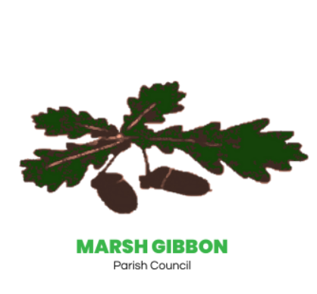

Play Equipment Survey Results
Marsh Gibbon Parish Council

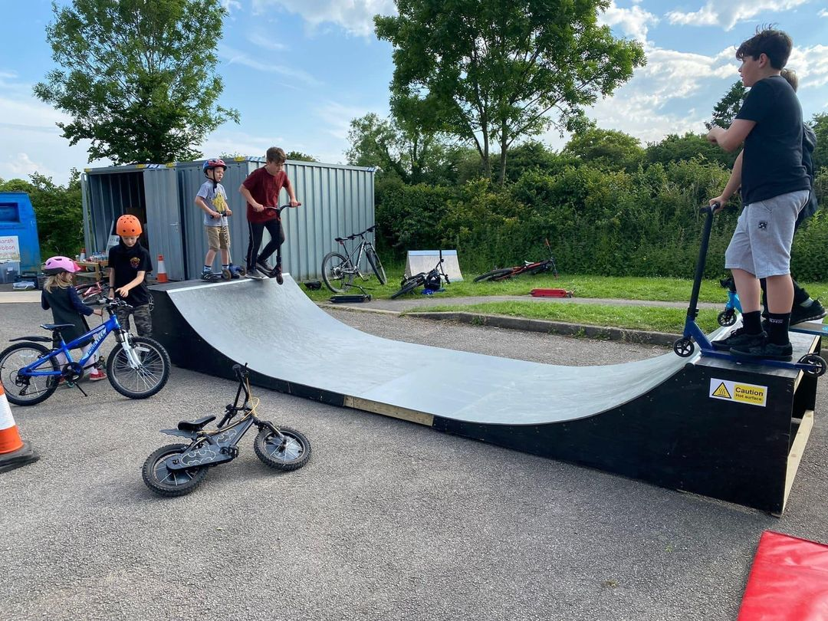

Question 1
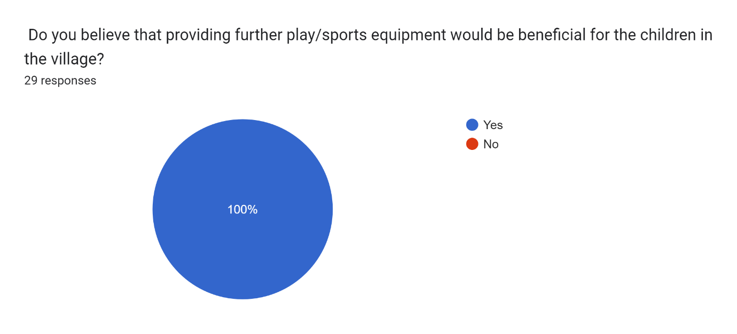

Question 2
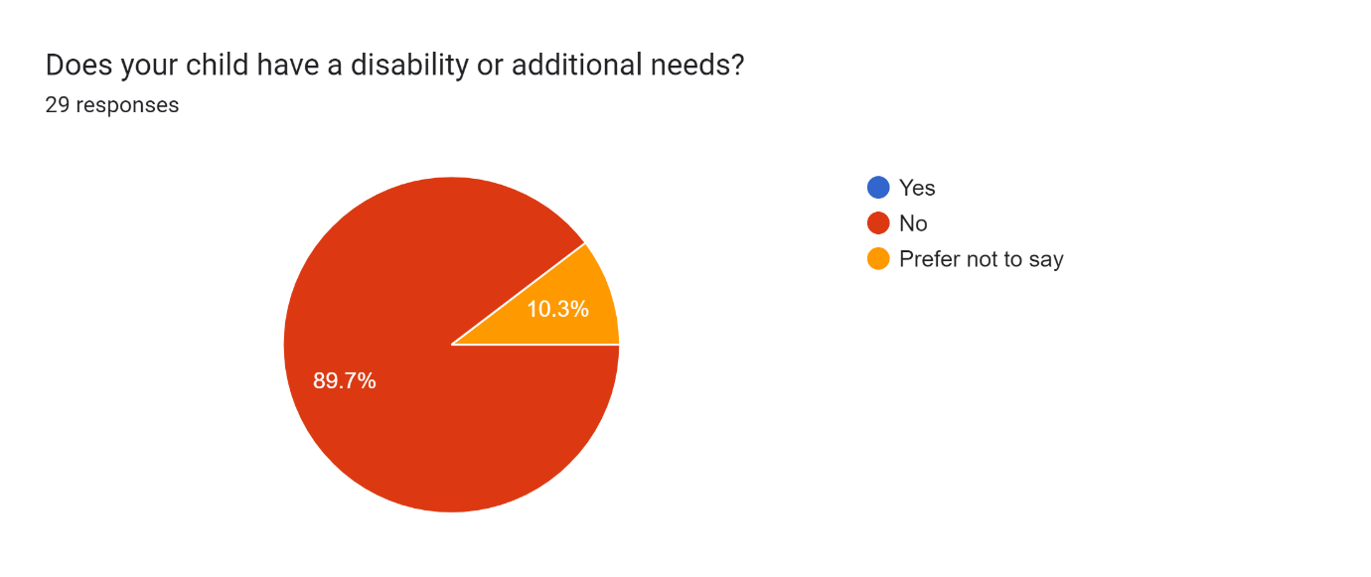

Question 3
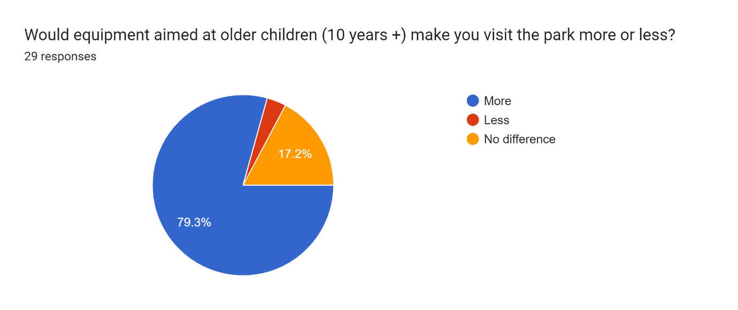

Question 4
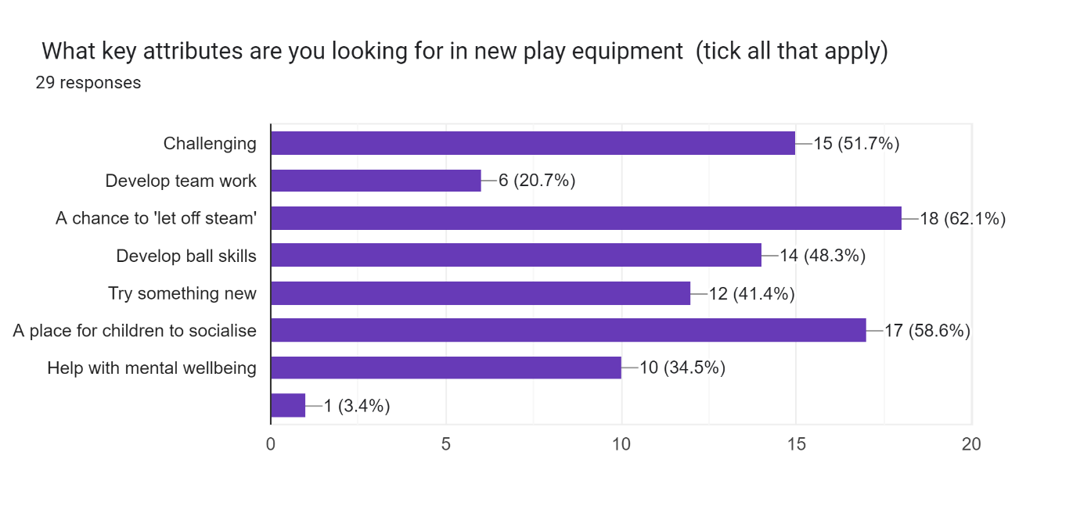

Question 5
In order of your preference, with 1 being the most important and 5 being the least important. Please rank each item below for inclusion in the new park.
Overall Ranking | Item
1 (Most Important) | Skate ramp | 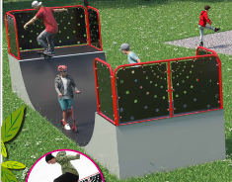
2 | Basketball court | 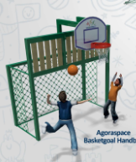
3 | Climbing wall/unit | 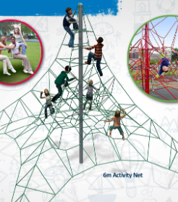
4 | Table tennis table | 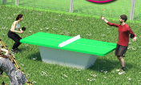
5 (Least important) | Football Goal | 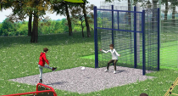

Question 6
Do you have any other ideas for the development of the park?
Note: For those responses that are similar, we have grouped them into the same category.
Idea | Response
Add more equipment to the actual playground | The small children’s playground is currently at capacity with the current footprint. Also, the funding for this project is only eligible to be used in the all-weather pitch area.
- I like the idea of skate park equipment and ramps to extend the skate park session. Maybe an open sheltered area.  - A skatepark for the teenagers  - Skatepark  - Skate ramp of some sort would be fantastic for the older children in the village  - More ramps | As the skate ramp/park came out as the top item on the survey we will be perusing this as a priority item.
- Yes - a BMX track that can also be used for skateboards. We were on holiday in south Devon this month and they have an excellent BMX pump track and velopark facility and I think Marsh Gibbon could benefit from something similar - please see https://www.leisurecentre.com/torbay-leisure-centre/velopark  - A pump track would be great for bmx skills.  - A bike track! | This was certainly a popular item suggested in the survey and anecdotally to Parish Councillors. The cost of this item maybe a prohibitive factor but we have begun to investigate with various suppliers of how this might be installed at a reasonable price.
- Older children (mainly girls!?) love swings. How about some swings for older children away from the younger children’s play area? | We will certainly get some prices to install further swings and come back out with some information.
- What about a fitness/obstacle course for older children/teenagers? The current course is largely unachievable for most adults. | As above, we will endeavour to get some costings on this.
- Another covered seating area would be good (like the one at the far end of the zip line) for inclement weather. | As above.
- I would not install an additional football goal as there is already the all-weather pitch - money could be better spent. I’ve seen a fair number of table tennis tables at other parks, and they are largely unused. | As the football goal was the least desired item within the survey, we will not be pursuing this as a priority item.  The table tennis table was cheapest of all items so there could a possibility to add this as an extra item but the priority will be on other items.
- I think it’s also worth considering also having some open grass space for picnics etc.  - Include planting for wildlife.  - Maybe some wild space  - Safe lighting, first aid box, science elements, bugs and insects | The intention is not to cover all the green space with equipment but to leave some space for people to picnic.  In terms of adding wild space this would perhaps be something to review within a future project but certainly a good idea.  A great idea we will certainly investigate a first aid box and if there is a potential for some sort of lighting.

Question 7
Do you have any concerns about any of the equipment outlined or the idea of developing the playpark?

Concern | Response
- Skatepark | Without further details we can’t comment on this concern. When we have further details in relation to the skatepark we will outline this for further comment.
- I just hope it isn’t vandalised.  - Anti-social behaviour | Agreed, we will need to ensure that this isn’t vandalised as we cannot afford to replace items.  We hope by involving the community in the decisions and implementation this will help everyone to take pride in the facilities.  We will however engage with the local PCSO team to ensure we are doing everything we can to discourage any anti-social behaviour.
- Putting so much in this area means there’s more chance of kids wanting to separate, especially siblings, which may prove a challenge!  - Younger children not being supervised on the skate park and running in front of older children doing tricks | Unfortunately, with all this equipment it will be up to parents to supervise their children and ensure they are safe during any visit to the park.  If implemented the skatepark will be outlined as a ‘use at own risk’ piece of equipment and it will be up to parents to review if they are comfortable with their children using this item.
- I would worry about the safety aspects of the rope activity net (falling off) and would not want my children climbing on it. | All pieces of equipment will meet the necessary safety standards and have the appropriate surfacing. It would be therefore for parents to ascertain if they are comfortable with their child using this equipment.  However, we will endeavour to look at other options for the climbing feature and present these back.
- A lot of the items in design 2 seem a waste, as they only allow one child to use it at a time. I would rather see money spent on things that encourage group play. | Agreed, we will need to ensure that we maximise the use of any equipment we have.
- Materials should be as durable but also as sustainable as possible | Absolutely, we certainly want these items to last but equally we are a rural location and do not want to be pouring tons of concrete or plastic into the ground.  We will be looking at items that have the lowest environmental impact on the surrounding area.
- My children absolutely love the zip wire (favourite part of the park), does that mean this would go? | We can categorically say that we will not be removing the zip wire or any of the other equipment located in the park. This development must compliment what we already have.

Question 8
Are there any further general comments you wish to make?

Comment | Response
- I really hope this project is completed - it will be a great asset to the village. | We will endeavour to ensure that it is completed.
- Thank you for doing this. It is appreciated.  - Great to see this happening to make our village an even nicer place.  - Thanks for all the hard work with this! | Thank you, the positive comments are appreciated.
- Make a skatepark.  - Skatepark | As this is the number one priority, we will do our very best to make this happen.

Conclusion
We first would like to thank everyone who took the trouble to complete the survey. From the feedback and comment’s, we can see that the main desire is for skate ramps and a BMX track for older children. We will therefore pursue these items as a priority and to see what further quotes might be available. We will try to take on as much of the requests and feedback as possible but there will inevitably be compromises due to the space and costs i.e. any climbing activity may have to be scaled down to allocate more resource to the basketball court or skate ramp as these were deemed more popular. What we will do is come back and showcase any further quotes and ideas that we have. As we stated at the start of the survey there is no hard deadline for this work but if we can get the necessary information and the right price then installation in summer 2024 is certainly achievable.

